

-Sharad Vadehra, Managing Partner

Aakriti Vadehra, Patent Engineer

“Assessing the Chances of Acceptance of the TRIPS Waiver Proposal”

KAN NEWS

Volume VI 2021: May-I

**Sharad Vadehra** of the firm **KAN AND KRISHME** is an Advocate practicing before the New Delhi High Court and a Registered Patent and Trademark Attorney. He specializes in drafting of patent specifications, patent and trademark litigation, opinions on patentability in

**Col. Krishan Lal Vadehra** of thefirm **Kan And Krishme** earned his Bachelors of Science in Mathematics and Mechanical Engineering from Thappar Institute of Engineering and Technology, Patiala. He earned his M.Tech degree in Automobile Engg. from the Military College of Electronic

**SENIOR PARTNER, KAN AND KRISHME**



Electronic and Mechanical Engineers, Secunderabad, India. He is a Registered Patent Attorney and holds membership of **MIE(I), MIMA, MIPE, AMBIM, FICPI** and **APAA**. His field of specialization includes patent drafting and prosecution of telecommunications, mechanical, electrical, electronic and automotive engineering patents. Before becoming a Patent Attorney, he served in the Indian Army for 30 years in various technical and managerial assignments in electrical, automotive, mechanical engineering and field of wireless telecommunications. He heads the Electrical, Electronic, Mechanical and Telecommunications Department of **Kan and Krishme.**

**MANAGING PARTNER, KAN AND KRISHME**

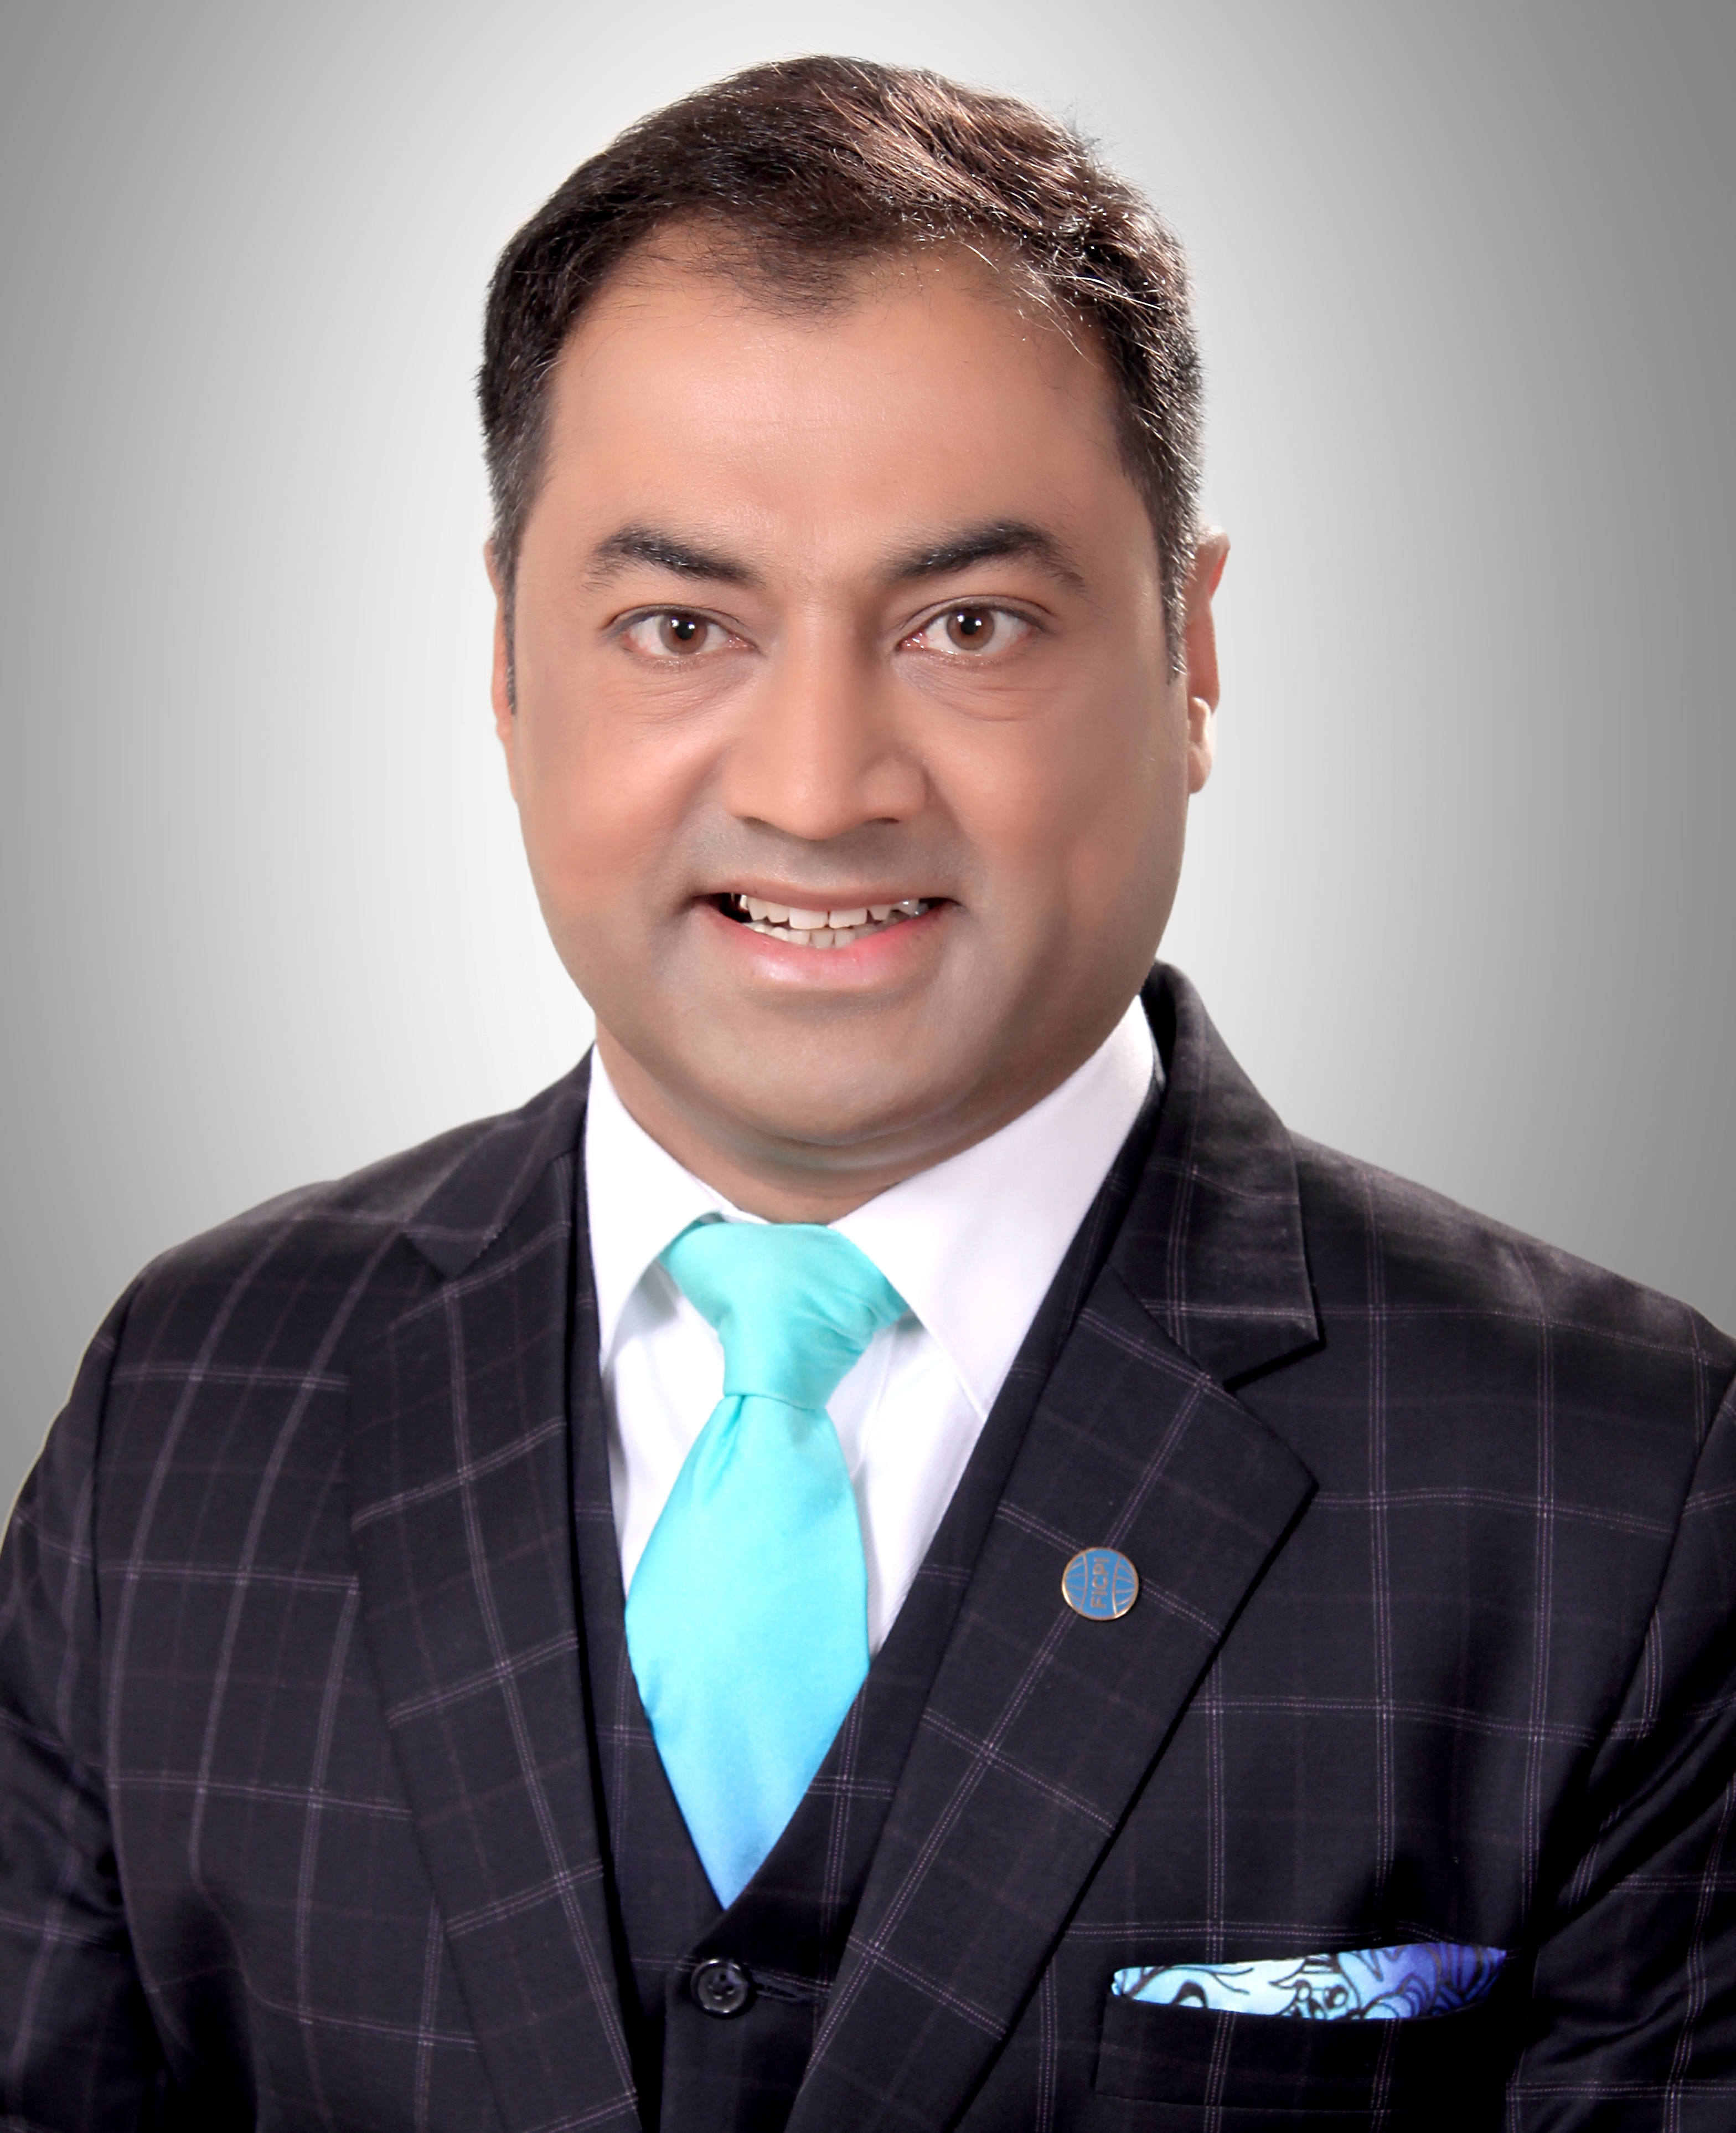

in India, infringement proceedings and trademark prosecution as well as pre-grant and post-grant oppositions. He is a member of **APAA, AIPLA, AIPPI, INTA, LES, GALA, FICPI & CII**. He is one of the founding members of the FICPI India Group and GALA. He has been re-elected as Vice-President of APAA-India. He has delivered lectures and presentations on IP Law and practice in India in more than 300 institutions and corporate bodies in India and overseas. He has prosecuted more than 4000 patent and trademark applications.

The Proposal raised concerns about the limited availability (and shortage) of diagnostics, therapeutics, and vaccines for COVID-19, including medical products such as diagnostic kits, medical masks, protective equipment, ventilators, etc. Citing an [article by Bloomberg](https://www.bloomberg.com/news/articles/2020-03-20/world-war-ii-style-production-may-carry-legal-risks-for-patriots), the proposal stated how “*intellectual property rights hinder or potentially hinder timely provisioning of affordable medical products to the patients*.”

In response, the United States demanded clarification and proof as to how “the identified TRIPS obligations have systematically hindered or blocked the prevention, containment or treatment of COVID-19?”

**Relevant Sections of the TRIPS Agreement**

[Section 1 – Copyright and Related Rights](https://www.wto.org/english/docs_e/legal_e/27-trips_04_e.htm)

[Section 4 – Industrial Designs](https://www.wto.org/english/docs_e/legal_e/27-trips_04b_e.htm#4)

[Section 5 – Patents](https://www.wto.org/english/docs_e/legal_e/27-trips_04c_e.htm)

[Section 7 – Protection of Undisclosed Information (Trade Secrets)](https://www.wto.org/english/docs_e/legal_e/27-trips_04d_e.htm)

THE TRIPS WAIVER PROPOSAL

On October 2nd, 2020, India and South Africa, in a [joint proposal](https://docs.wto.org/dol2fe/Pages/SS/directdoc.aspx?filename=q:/IP/C/W669.pdf&Open=True) moved the World Trade Organization (WTO) for “*a waiver from the implementation, application, and* *enforcement of Sections 1, 4, 5, and 7 of Part II of the Trade-Related Aspects of Intellectual Property Rights (TRIPS) Agreement in relation to prevention, containment or treatment of COVID-19*”, for a limited period of time “*until widespread vaccination is in place globally, and the majority of the world's population has developed immunity.*” Most of the developing and least developing countries (LDCs), as well as many civil society groups and labor unions, doctors’ organizations such as the *Medcin sans Frontiers* (MSF), academic institutions, and millions of individuals around the globe, support the proposal. Whereas, developed countries like Australia, Brazil, Canada, European Union, Japan, Norway, Switzerland, the United Kingdom, and the United States continue to oppose the proposal, to this date.

KAN NEWS

**YOUR INDIAN CONNECTION KAN AND KRISHME, Attorneys at Law**

The European Union replied, “…Domestic legal frameworks should properly reflect the flexibilities provided by the TRIPS agreement, such as the possibility of issuing a compulsory license, including for production for export to vulnerable countries that lack production capacity or including fast-track procedures that can be used in health emergencies…”

LATEST STATEMENT BY THE UNITED STATES

In a surprising turn of events, on May 05, 2021, the United States Trade Representative (USTR) Katherine Tai released a [statement](https://ustr.gov/about-us/policy-offices/press-office/press-releases/2021/may/statement-ambassador-katherine-tai-covid-19-trips-waiver) that the Biden-Harris Administration supports the waiving of intellectual property protections for COVID-19 vaccines. This statement came a few days after the USTR met with vaccine manufacturers Pfizer and AstraZeneca, in an attempt to encourage them to offer licensing to the rest of the world.

USTR has stated, *“the Administration believes strongly in intellectual property protections, but in service of ending this pandemic, supports the waiver of those protections for COVID-19 vaccines. We will actively participate in text-based negotiations at the World Trade Organization (WTO) needed to make that happen.”*

A very important point to note here is that the USTR statement does not refer to the TRIPS waiver proposal by India and South Africa but only to the waiver of intellectual property protections for COVID-19 vaccines. As discussed above, the proposed waiver is broader than mere vaccines.

Whether the released statement by the USTR regarding waiver of intellectual property protections for COVID-19 vaccines will include technology transfer, technical know-how, and more, remains to be seen.

IS WAIVER THE ONLY SOLUTION?

The short answer? No. While a waiver is a good option, we cannot deny the existence of more solutions, such as:

1. TRIPS flexibilities
2. Provisions available in respective countries’ legal systems
3. Initiatives by the World Health Organization (WHO)

# **TRIPS Flexibilities**

The TRIPS Agreement provides minimum standards of protection which each member state of WTO must give to the intellectual property of the other member states. However, the Agreement also allows certain flexibilities that “*aim to permit developing and least-developed countries to use TRIPS-compatible norms in a manner that enables them to pursue their own public policies, either in specific fields like access to pharmaceutical products or protection of their biodiversity, or more generally, in establishing macroeconomic, institutional*

*conditions that support economic development.”* [1]

The flexibilities that may be used in the present scenario include reducing or limiting the rights conferred to the patentee (through experimental use or the Bolar Exception), issuing compulsory licenses (viable only for countries with manufacturing abilities), or issuing voluntary licenses.

However, as submitted by India and South Africa, “*many countries especially developing countries may face institutional and legal difficulties when using flexibilities available in the Agreement on Trade-Related Aspects of Intellectual Property Rights (TRIPS Agreement). A particular concern for countries with insufficient or no manufacturing capacity are the requirements of Article 31bis and consequently the cumbersome and lengthy process for the import and export of pharmaceutical products.”*

## Provisions Available in the Indian Patents Act, 1970 (as amended)

The Indian Patents Act, 1970 (as amended) provides multiple ways of resolving the current IPR issues in view of the pandemic, without having to rely on the TRIPS waiver. Some of them include:

* Revocation of Patent in Public Interest under Section 66;
* Compulsory License under Section 92;
* Power of the Central Government to use inventions for the purpose of Government under Section 100.

**Article 31*bis***

Article 31*bis* was amended into the TRIPS Agreement for WTO member states to issue a compulsory license for manufacturing, while also allow them to export (and import) generic pharmaceutical products to/from other member states. The possible legal and institutional difficulties that the proposal mentions about Article 31 *bis* could be:

* High-income countries like Australia, Canada, EU, Switzerland, Iceland, Norway, Japan, New Zealand, UK, and the US have all opted out of the Article 31*bis* system.
* The country that issues a compulsory license to export drugs to another nation, has to ensure that those drugs are exported to that nation only.
* The drugs exported should be easily identifiable through different colour, shape, or packaging.

KAN NEWS

**YOUR INDIAN CONNECTION KAN AND KRISHME, Attorneys at Law**

Out of the above options, a lot of countries that oppose the waiver have based their opinion upon the option of issuing a compulsory license. Let’s discuss this option in detail:

### **Compulsory License**

[Section 92](https://indiankanoon.org/doc/986301/) of the Indian Patents Act, 1970 (as amended) provides that, *“in circumstances of national emergency or of extreme urgency”*, the Central Government may declare that a compulsory license is issued for a patent in force.

In simpler terms, Indian companies can apply for a compulsory license to get limited rights to a patented invention, in exchange for royalty paid to the patentee. Being a member of the TRIPS Agreement, under the Doha Declaration, India has a right to grant a compulsory license, especially given the present circumstances of public health emergency.

Having said the above, it is worth noting that many international COVID-19 vaccine producers such as AstraZeneca, have already granted a voluntary license to Indian companies such as Serum Institute of India, Dr. Reddy Laboratories, and more. Moreover, Johnson & Johnson, Moderna, and Pfizer-BioNTech have licensed their intellectual property at no cost. A voluntary license renders the need of a compulsory license *void ab initio*.

Even if a compulsory license were to be issued, it is important to note that the patentee is not liable to share the technical *know-how* of his invention, as it is an entirely different kind of intellectual property than a patent. Without the technical *know-how,* it may be difficult to reverse engineer and reproduce a vaccine indigenously. Even though CIPLA and Ranbaxy Ltd. managed to reverse engineer the anti-retroviral drugs developed to treat HIV back in 2005, the technology being used in the current COVID-19 vaccines, i.e., the m-RNA technology, is novel and different from the traditional *know-how*.

## Initiatives by WHO

Since the spread of COVID-19, the WHO has introduced some initiatives to help the world deal with the pandemic. Some of them include the COVID-19 Technology Access Portal (CTAP), the Access to COVID-19 Tools (ACT) Accelerator, COVAX, and technology transfer hubs.

The COVID-19 Technology Access Pool (C-TAP) compiles, in one place, pledges of commitment made under the Solidarity Call to Action to voluntarily share COVID-19 health technology-related knowledge, intellectual property, and data.[2] Further, the Access to COVID-19 Tools (ACT) Accelerator is a global collaboration to accelerate development, production, and equitable access to COVID-19 tests, treatments, and vaccines.[3] The popular COVAX program is the “vaccines pillar” of the ACT Accelerator. Furthermore, WHO has facilitated the establishment of technology transfer hubs to transfer a comprehensive technology package (initially, mRNA-vaccine technology) and provide appropriate training to interested manufacturers in Lower- and Middle-Income Countries (LMICs).[4]

While these initiatives were a ray of hope to the LMICs, we cannot ignore that the CTAP failed to garner enough support, with only 40 countries (mostly lower- and middle-income countries) supporting the call. As regards COVAX, the problem lies in the inherent aims of the program, i.e., it aims at immunizing only 20% of national populations; any additional supply of vaccines would be offered to countries in line with a needs-based allocation framework.

**COMPROMISE BY INDIA AND SOUTH AFRICA**

Amid opposition by numerous High-Income countries (of which the US was a part, until recently), India and South Africa have come to the decision of reviewing their initial proposal of TRIPS waiver. The two countries have collectively decided to submit a new and revised proposal to the WTO General Council, in the hopes that it may mollify the opposite parties, and give more detail into how the current options (as discussed) are not sufficient.

CONCLUSION

From the above discussion, it is clear that a waiver of the TRIPS Agreement is not the only solution to the present problem. While each alternative has its difficulties, the fact that alternatives exist is in itself a testament to the success rate (or lack thereof) of the General Council and the member countries of WTO accepting the TRIPS waiver proposal.

However, after the May 05, 2021 meeting of the WTO General Council, India and South Africa’s decision to revise their proposal, and the US’s new stance, the chances of a new proposal possibly being accepted are not suddenly looking bright. It still remains to be seen what India and South Africa will now submit in the form of an amended proposal.

For now, India’s best shot would be to rely on its indigenous vaccine COVAXIN, manufactured by Bharat Biotech. Amplifying vaccine production and vaccinating its citizens is key to bringing down the curve that has risen exponentially during the second wave of COVID-19 in India.

**References**

*[1]*[*https://www.wipo.int/ipdevelopment/en/policy_legislative_assistance/advice_trips.html*](https://www.wipo.int/ipdevelopment/en/policy_legislative_assistance/advice_trips.html)

*[2]*[*https://www.who.int/initiatives/covid-19-technology-access-pool/what-is-c-tap*](https://www.who.int/initiatives/covid-19-technology-access-pool/what-is-c-tap)

*[3]*[*https://www.who.int/initiatives/act-accelerator/about*](https://www.who.int/initiatives/act-accelerator/about)

*[4]*[*https://www.who.int/news-room/articles-detail/establishment-of-a-covid-19-mrna-vaccine-technology-transfer-hub-to-scale-up-global-manufacturing*](https://www.who.int/news-room/articles-detail/establishment-of-a-covid-19-mrna-vaccine-technology-transfer-hub-to-scale-up-global-manufacturing)

KAN NEWS

**YOUR INDIAN CONNECTION KAN AND KRISHME, Attorneys at Law**

|  |  |
| --- | --- |
| Visiting and Correspondence Address:**KAN AND KRISHME®** KNK House, A-11, Shubham Enclave,  (Opposite Radisson Blu Hotel)  Paschim Vihar, New Delhi-110063, India | **Satellite Offices:**  Chennai, Mumbai and Kolkata |
| **Registered Office:** **KAN AND KRISHME®** KNK House, B-483, Meera Bagh,  Paschim Vihar, New Delhi-110063, India | **Representative Offices:**  Nepal, Bhutan, Bangladesh, Pakistan, Sri Lanka, Myanmar & Maldives. |
| **Contact Details:**  Telephone: 91-11-43776666 (100 Lines)  Facsimile: 91-11-43776676, 43776677  Website: <http://www.kankrishme.com>  E-mail: [knk@kankrishme.com](mailto:knk@kankrishme.com) | **Member:**  **INTA, FICPI, GALA, LES, AIPPI, APAA, AIPLA, CII** |